DEACOMART _Development and Empowerment of Agri-food Communities for Market Resilience, Training and Transformation
D Development
E Empowerment
A Agri-food
CO Communities
MA Market
R Resilience
T Training
T Transformation

About us

DEACOMART Limited is a Rwandan private limited company established and registered in accordance with Article 23 of Law N° 007/2021 of 05/02/2021 governing companies in Rwanda. Incorporated on 27 October 2025, the company was created with a clear purpose: to strengthen Rwanda's agri-food value chain by delivering high-quality food processing, wholesale distribution, and retail services to local and regional markets.
DEACOMART operates with a deep understanding of Rwanda's food and agricultural landscape — and its integration into regional and global agri-food systems. The company adopts an integrated, quality-driven, and market-oriented approach to serve its partners and clients, while upholding the highest standards of regulatory compliance and business ethics.
Rooted in a strong commitment to quality, reliability, and integrity, DEACOMART is actively contributing to Rwanda's food security ambitions and the broader socioeconomic transformation goals set out in the National Strategy for Transformation (NST-1) and its successor, the Second National Strategy for Transformation (NST2, 2024–2029), anchored in Vision 2050.

HOME
Dear guest, you are warmly welcome to the website of DEACOMART Limited, Development and Empowerment of Agri-food Communities for Market Resilience, Training and Transformation. DEACOMART is a Rwandan Agri-food Development and Training Company established to strengthen Rwanda's agri-food value chain and empower farming communities, agri-entrepreneurs, and food businesses through Food processing & Value addition, wholesale distribution, and structured capacity building programmes.

DEACOMART Limited is a Rwandan Agri-food Development, Processing, and Training Company, incorporated on 27 October 2025 and registered under Article 23 of Law N° 007/2021 of 05/02/2021 governing companies in Rwanda. Born from a deep conviction that Rwanda's farming communities deserve better — better markets, better training, better tools, and better futures — DEACOMART was founded to be the bridge between where Rwanda's agri-food sector is today and where it needs to be by 2050.
With a deep understanding of Rwanda's food, agricultural, and market landscape — and its integration into the regional and global agri-food systems of East Africa and beyond — DEACOMART brings together processing, commerce, data-driven training, and community empowerment under one roof. We operate at the intersection of private sector dynamism and development impact — making us a uniquely positioned partner for investors, funders, and communities.
DukuzumuremyiEric,MSc (Founder &Chief Executive Officer)

Who should partner with DEACOMART
We are actively seeking partners, investors, and collaborators across these areas:
- Agri-food investors and impact funds
- Development organisations (FAO, WFP, IFAD, GIZ, AEE, KILIMO TRUST)
- Farmer cooperatives and producer groups
- Training institutions and universities
- Food retailers, hospitality, and institutional buyers
- District agriculture offices and local government
- East African regional agri-food businesses
- Data, M&E, and technology partners
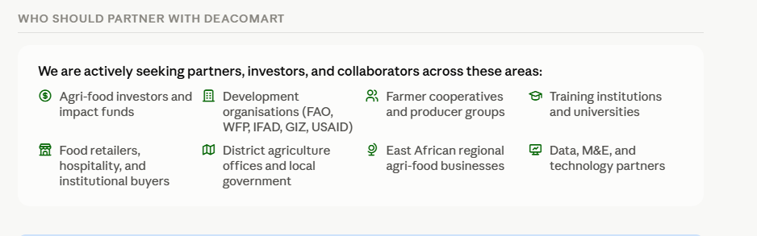

What we do
- Wholesale & agri-trade: Distributing food, beverages, and agricultural raw materials to local, regional, and export markets
- Training & capacity building: Agriculture production, Marketing, Food value chain, food safety, postharvest management, and tax literacy training
- Resilience building: Equipping communities to absorb climate shocks, reduce losses, and sustain livelihoods
- Data & transformation
- Statistical tools including Stata for agri-food data analysis, M&E, and evidence-based farm decisions

Why DEACOMART — four reasons to engage
Right sector, right time
Agriculture is Rwanda's top NST2 priority. DEACOMART sits at the heart of it — processing, distributing, and training across the full value chain at exactly the moment Rwanda needs it most.
Integrated model
Unlike single-service operators, DEACOMART combines food processing, wholesale, retail, training, resilience building, and data skills into one powerful, interconnected platform.
Community at the centre
Farmers, cooperatives, women, youth, and entrepreneurs are not beneficiaries — they are partners. DEACOMART's model is designed with and for communities, not just for them.
Data-powered decisions
DEACOMART trains agri-food professionals and cooperatives in data management and Stata — bringing evidence-based decision-making to Rwanda's farming communities for the first time.
